Flask Lab

Example 1:

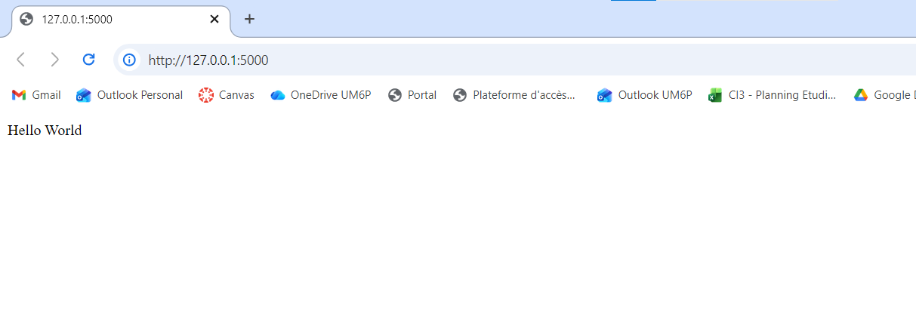

Example 2:

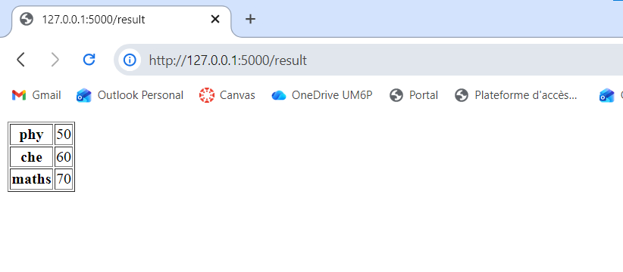
Example 3:

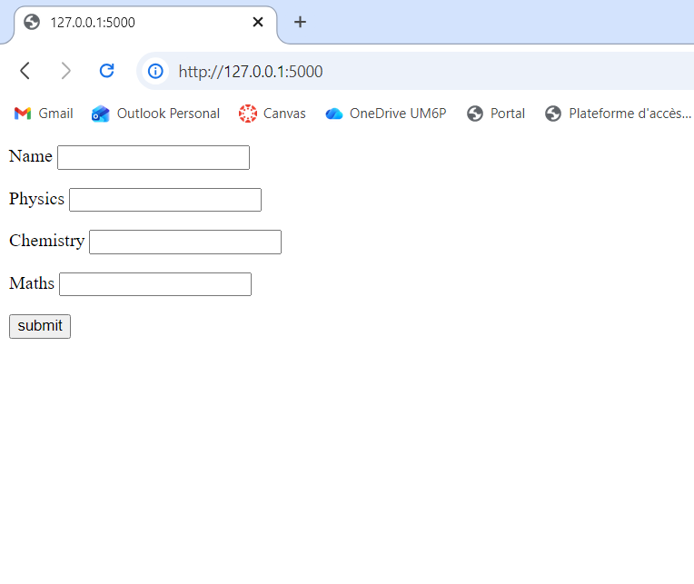
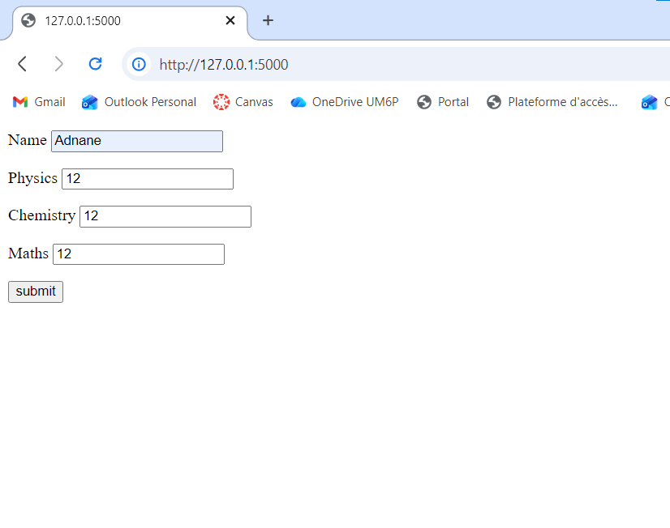

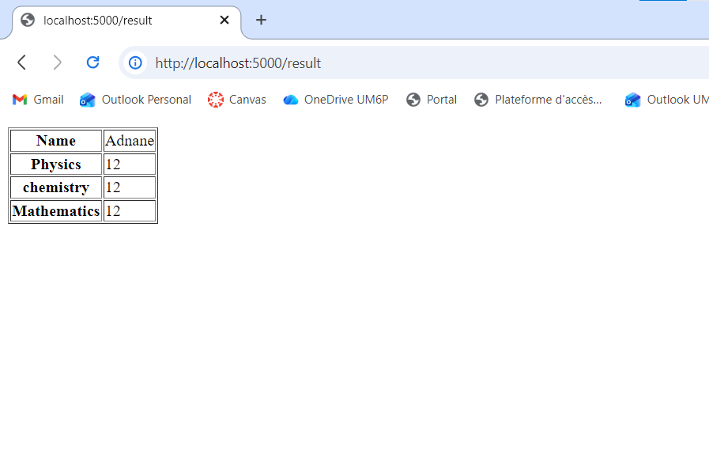

Furniture prediction:

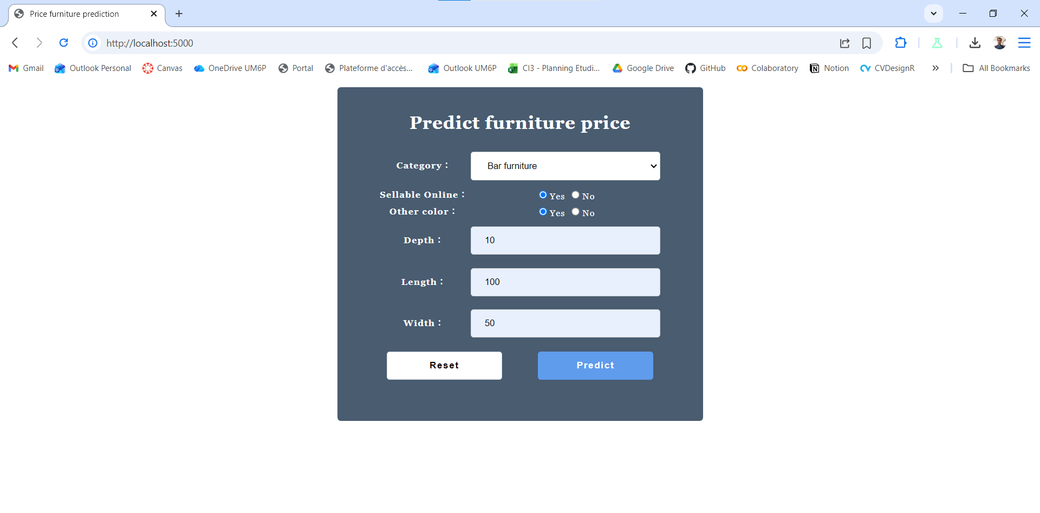

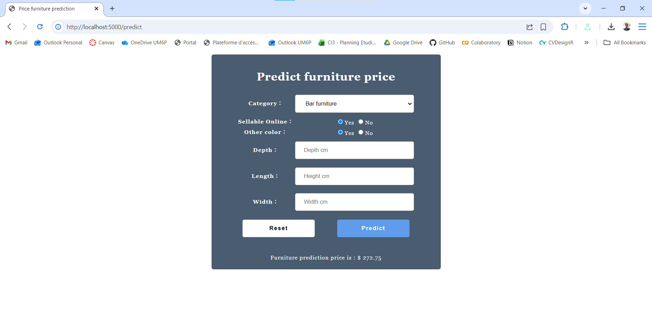

Python Libraries FastAPI

- Introduction to Pytest

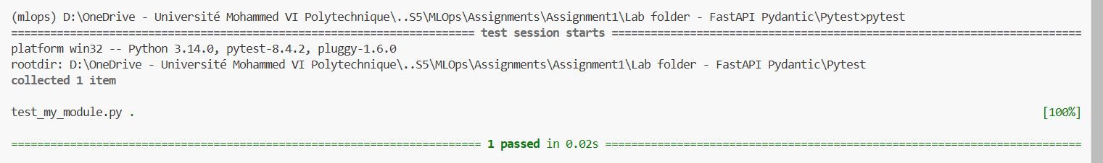

After changing value 4 to 7:
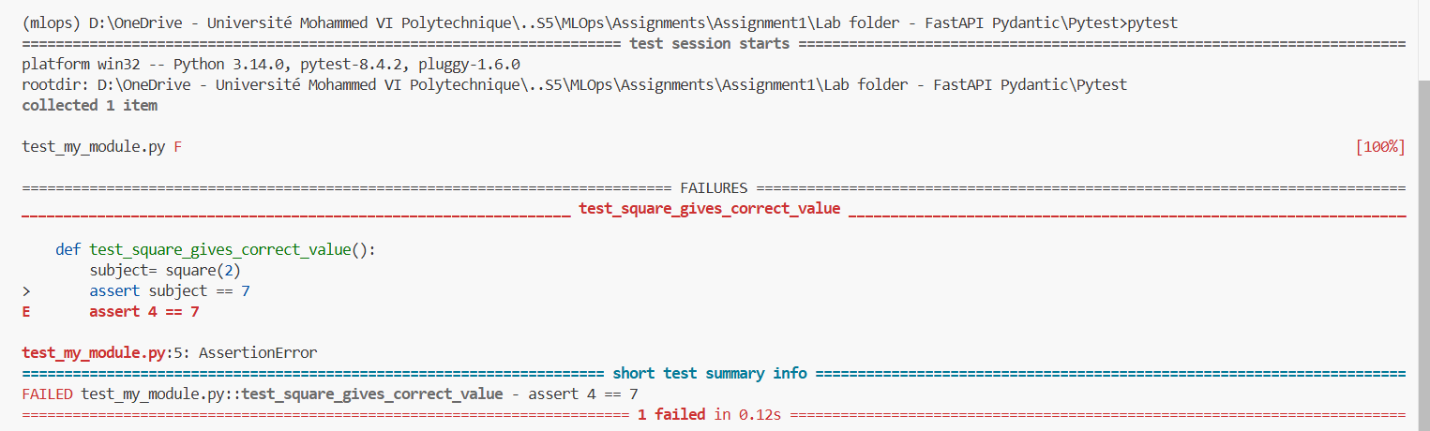

After using fixture:
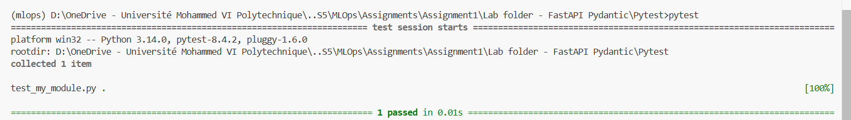

After adding another test:
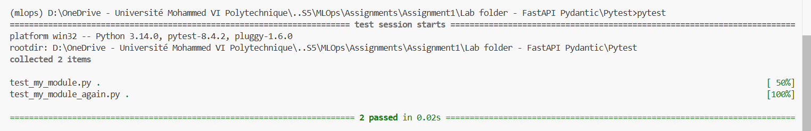

Using conftest.py:

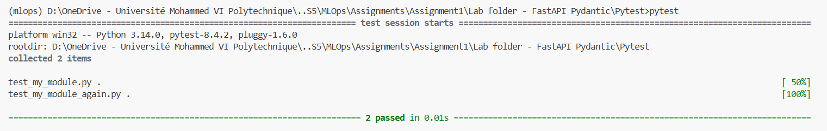

Paramaterized test:

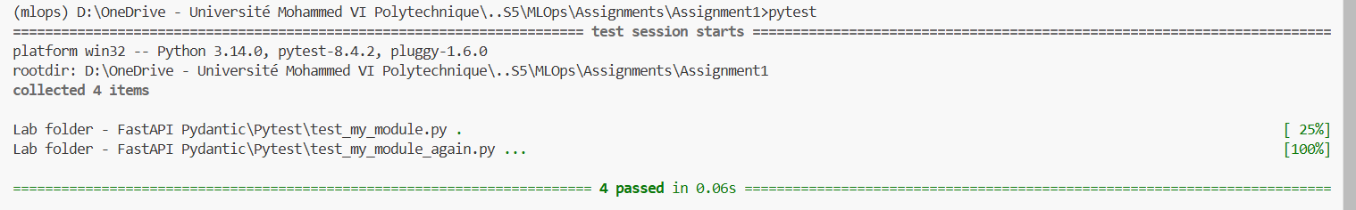

- Introduction to Pydantic
Example 1:
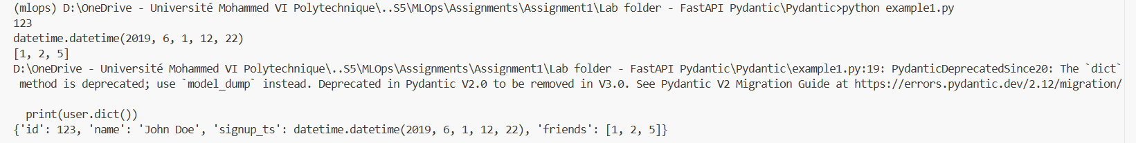
This converted types to pydantic types: id '123' → int 123, '5' → 5, signup_ts string → datetime

Example 2:
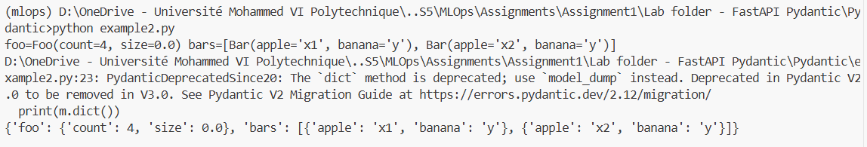

Validator:
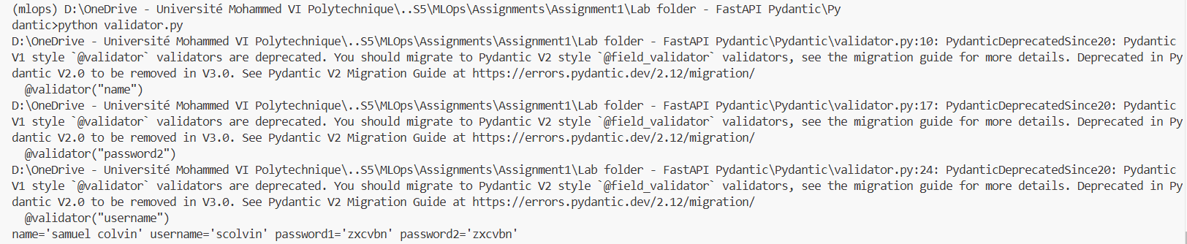

- Introduction à FastAPI

